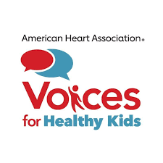

Tips for Writing a Press Release

A press release is used to announce new information, new facts, or milestone accomplishments of your campaign. Press releases can also be used to respond to something that has happened externally that affects you. If you’re submitting it to a local media outlet, it is critical that the information is locally focused with a local spokesperson quoted, if possible. Press releases can also provide “hero opportunities” to your legislative allies, so invite them to submit a quote for inclusion.

- Use digital letterhead, double space and leave ample margins.

- Include contact name/position/telephone number/email in upper right-hand corner.

- Under contact name, put the release date: (“For Immediate Release: Date”)

- Your headline should be short, catchy and in bold letters. Make sure to use active voice.

- Include all pertinent information. If you’re talking about an event, include specifics.

- Include quotes from relevant organizations or spokespeople. Make sure the quote is approved by speaker.

- But… don’t use too many quotes. While it is part of the campaign manager’s job to provide equitable opportunities for all coalition partners to shine, every coalition partner does not need to be quoted in every release. Spread the glory around over time!

- Signal the end of the release with three pound signs. (###)

- If you are emailing the press release to a media outlet, paste the text of the letter directly into the body of your email. Many reporters will not open attachments.

- After emailing/faxing press release, follow up with reporters by phone or email to ensure they received it and answer questions.

