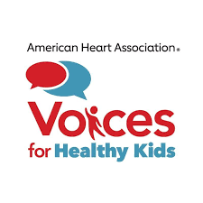

Worksheet: Who Do You Know?
Personal Relationship Profile

Your Name:
Voting Address:
Phone Number:
Email:
Social Media Used: ___ Facebook ___ Instagram ___ Twitter ___ Other

Our campaign will benefit from being connected to key players through people they already know and trust, like you! If you have friends, family, and other personal contacts in the categories listed below AND you are willing to reach out to them on behalf of the campaign, please let us know!

Do you personally know any elected officials?
Name of lawmaker:
Office held:
City/town:
Your relationship to lawmaker:

Do you personally know anyone who works in the media (newspaper, TV, other news source) in this state?
Name of media contact:
Media outlet where contact is employed:
City/town:
Your relationship to media contact:

Do you personally know any leaders from the business community (CEO, COO) or faith community?
Name of community leader:
Organization/business with which they are affiliated:
City/town:
Your relationship to community leader:

Do you have any other personal relationships that you think might be beneficial to the campaign? For example, someone who has expertise in an area related to this issue?

Name of individual:
Why you think they could be helpful to the campaign:
City/state:
Your relationship to that individual:

Do you know anyone who has been personally impacted by this issue or who is a member of the community most impacted by conditions you’re seeking to change?

Yes / No (Circle one)
Would you be willing to reach out to introduce them to the campaign and ask them to attend a meeting or phone call?

