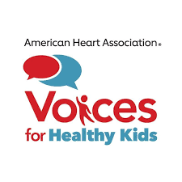

Give and Get of Strategic Partnerships for Coalitions

Partner categories | What will you give to the campaign? | What do you hope to get from the campaign?
Organizations that do NOT lobby
Organizations that DO lobby
Public agencies (local, state and federal)
Decision-maker champions
Organizations that can influence elections (PACs and 501(c)4s

