Participant Workbook

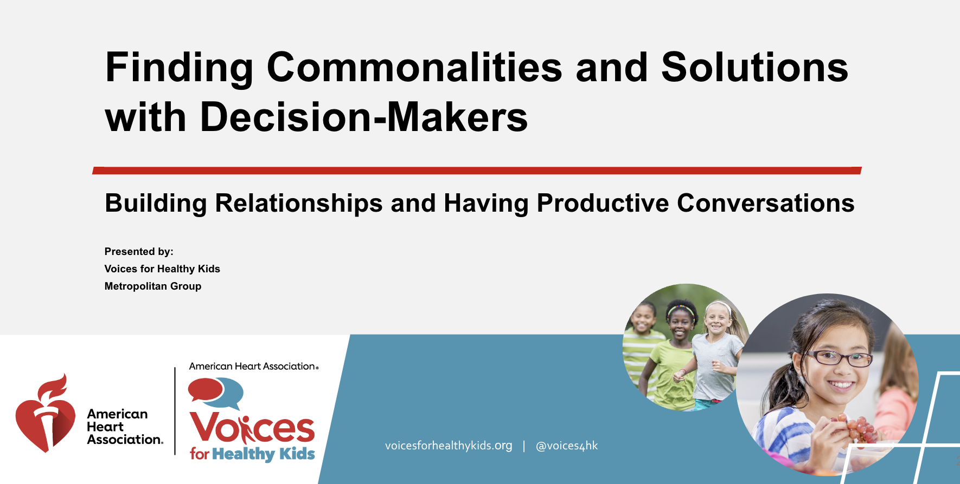

Use this workbook for notes and questions as you watch the webinars and attend a live workshop, TA session or discussion with your coalition.

Part 1 — Modules (access here)
About 70 minutes total to watch on your own, with the online guide as a supplement
- Module 1: Introduction and welcome (7 minutes)
- Module 2: Archetype overview (12 minutes)
- Module 3: Church & country (5 minutes)
- Module 4: Economic influenced (5 minutes)
- Module 5: Legacy Republican (5 minutes)
- Module 6: Populist-aligned (5 minutes)
- Module 7: Hidden feelings (14 minutes + optional 7 minutes on role of trauma)
- Module 8: PN-3 messages for the archetypes (9 minutes)
- Module 9: Local decision-making messages for the archetypes (9 minutes)

Part II — Live workshop or technical assistance session

Module 1: Introduction and welcome
Related online guide sections: Introduction | How to use this tool | Additional resources

What do you value?

In this work, how do you feel?

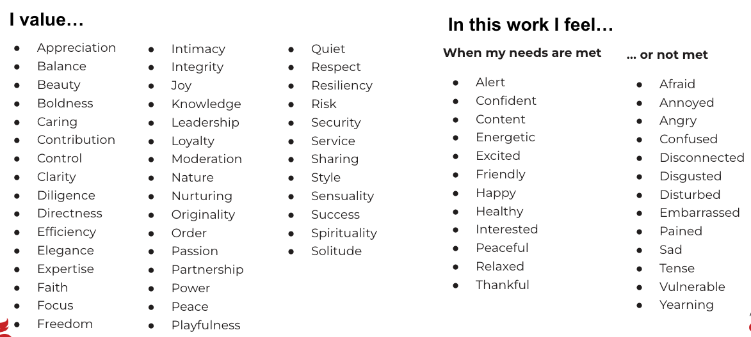

Module 2: Archetype overview
Related online guide sections: Methodology | Archetypes at a glance |
Characteristics across archetypes | Dials

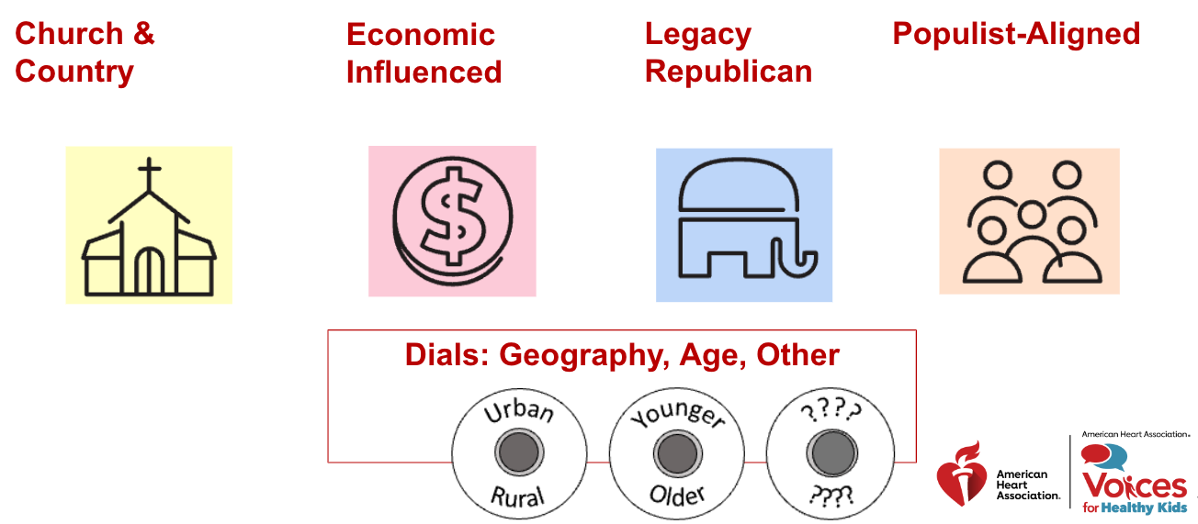

Notes:

Reflection questions:
  - How do you feel about these archetypes?
  - What resonates, or what might you adapt or add to the archetypes?
  - As you think about the conservative decision-makers you meet with, do you see them here?
  - Do you see yourself or others you know here? How does that inform your understanding?
  - Are there any questions or discussion points you’d like to bring to the live training, to a TA session, or to a discussion with your coalition?

Module 3: Church & country
Related online guide section: Church & country detail

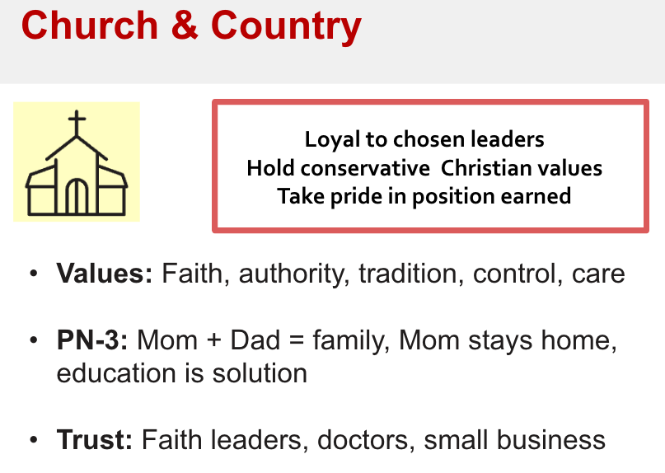

Notes:

Reflection questions:
- Think of a decision-maker in your district who fits this archetype. How might these insights help you prepare for conversation?
- What feelings does this bring up for you?

Are there any questions or discussion points you’d like to bring to the live training, to a TA session, or to a discussion with your coalition?

Module 4: Economic influenced
Related online guide section: Economic influenced detail

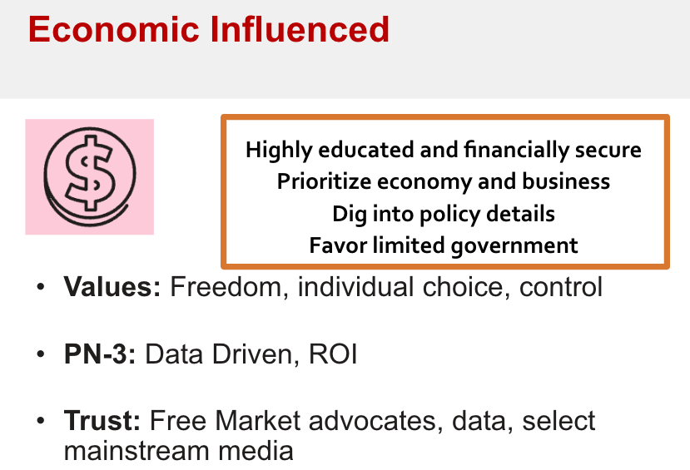
Notes:

Reflection questions:
- Think of a decision-maker in your district who fits this archetype. How might these insights help you prepare for conversation?
- What feelings does this bring up for you?

Are there any questions or discussion points you’d like to bring to the live training, to a TA session, or to a discussion with your coalition?

Module 5: Legacy Republican
Related online guide section: Legacy Republican detail

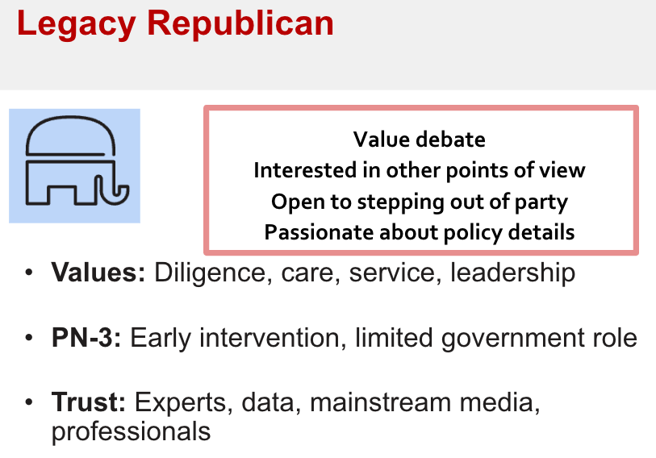
Notes:

Reflection questions:
- Think of a decision-maker in your district who fits this archetype. How might these insights help you prepare for conversation?
- What feelings does this bring up for you?

Are there any questions or discussion points you’d like to bring to the live training, to a TA session, or to a discussion with your coalition?

Module 6: Populist-Aligned
Related online guide section: Populist-aligned detail

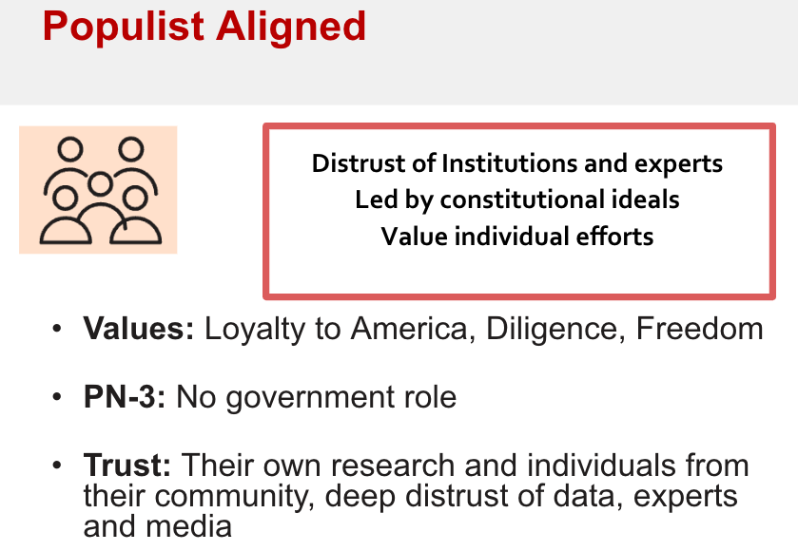
RESOURCE: For all archetypes, remember the coalition resources in the guide. Find them in the choosing the messenger and strategy section.

Notes:

Reflection questions:
- Think of a decision-maker in your district who fits this archetype. How might these insights help you prepare for conversation?
- What feelings does this bring up for you?

Are there any questions or discussion points you’d like to bring to the live training, to a TA session, or to a discussion with your coalition?

Module 7: Hidden feelings
Related online guide sections: Creating shared space | Hidden feelings role play exercise (Identifying needs & values) | Resources for the exercise

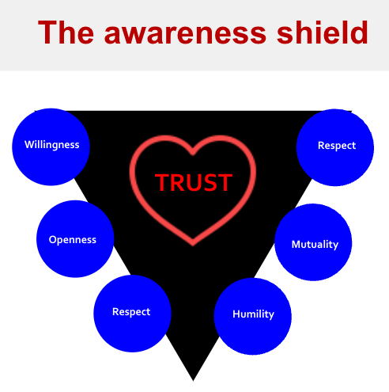

Notes:

Reflection exercise:
- Watch for your own hot spots that arise in conversations
- Use your feelings list to translate those hot spots into feelings
- Think about what you need to feel confident and safe in this work

Are there any questions or discussion points you’d like to bring to the live training, to a TA session, or to a discussion with your coalition?

Module 8: PN-3 messages for the archetypes
Related online guide sections: Customizing PN-3 messages | In conversation

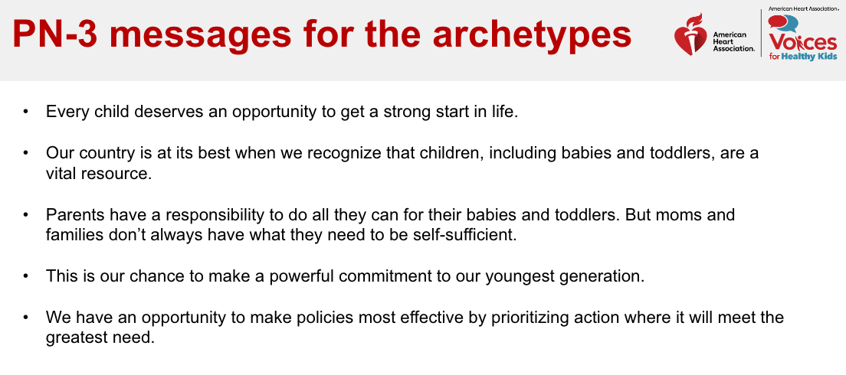Notes:

Reflection questions:
- How do you enter — safely — with curiosity?
- With specific archetypes, how have you framed your PN-3 ask?
- What have decision-makers said regarding PN-3 that makes you feel stuck?
  - How might the messages help?
- How can you invite further conversation?

Are there any questions or discussion points you’d like to bring to the live training, to a TA session, or to a discussion with your coalition?

Module 9: Local Decision-Making messages for the archetypes
Related online guide sections: Customizing local decision-making messages |
In conversation

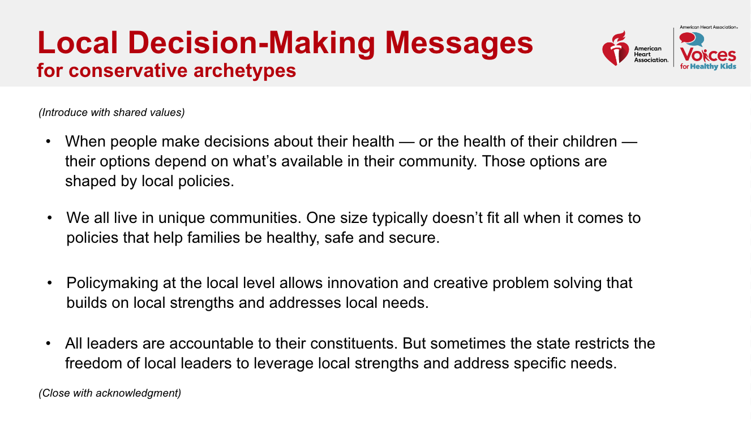

Notes:

Reflection questions:
- When you’re discussing the need for local decision-making, how do you start the conversation?
- What are some of the main concerns you hear?
- How do you frame your ask in response?
  - What shared values might create a different kind of opening?
- How can you invite further conversation?

Are there any questions or discussion points you’d like to bring to the live training, to a TA session, or to a discussion with your coalition?

Live workshop
Related online guide sections: Full guide | Resources for role play exercises

Notes:

Breakout 1: Understanding yourself—preparing for conversation

Introductions:
- Name
- Pronouns
- Organization and location
- Value and feelings in this work

Instructions

- Read the quote below to yourself and notice how you feel physically in your body and what feelings it brings up for you.

"Local control is good but sometimes the locals supersede the state. I’m a huge local control person — but I have to answer to my friends and neighbors back home. It’s when things are done that energize the base — when the city makes decisions that go against constituents’ voices. Guess whose phone rings?”
— State Representative, male, 54, rural/suburban

- Refer to the feelings, needs and values lists and make notes of your reactions—that is, any feelings or needs that come up for you when you imagine hearing someone say this to you.
- Discuss with your group.

You’ll have a little less than 10 minutes in your group.

If you get done early and need another quote to workshop, go to the exercise resources page, and scroll down for quotes.

Breakout 2: Identifying needs and values: Step two (translate a quote)

Instructions

- Ask one person to read the quote out loud. Imagine what the person saying this would be feeling in their body and what their emotions would be. Use the need, value and feelings lists plus your own intuition.
"Local control is good but sometimes the locals supersede the state. I’m a huge local control person — but I have to answer to my friends and neighbors back home. It’s when things are done that energize the base — when the city makes decisions that go against constituents’ voices. Guess whose phone rings?”
— State Representative, male, 54, rural/suburban

- Now, write down a nonpolarizing translation of the quote. If this person had spoken from a place of needs and values, what might they have said instead?
  - You’ll know you’re there when the quote doesn’t hold a charge any longer. Now it is depolarized; blame and shame have been distilled into an expression of shared humanity.
- Now, imagine the decision-maker had said the translated quote instead. How would you feel? How would you reply?
  - Try to stay focused on curiosity, listening and learning. You don’t need to jump directly to your issue yet! Seek to understand.
- Finally, read the original quote and see if the “flavor” of your reply works as a direct response to the quote. If not, edit your reply again until it does.

You’ll have a little more than 10 minutes in your group.

If you get done early and need another quote to workshop, go to the exercise resources page, and scroll down for quotes.

