Voices for Healthy Kids
Nourish from the Start Call for Applications
Policy Campaign Full Application (Word Template):

Welcome! Use this Word template to draft your responses, then copy them into the online grant system (Fluxx) to submit. (We can’t accept applications by email.)
Online system: voicesforhealthykids.fluxx.io

Helpful tips before you start:
- This template is just for drafting—your application is submitted in the online form in Fluxx.
- When you paste into Fluxx, formatting can shift (this is common). After pasting, use the preview/save screen to double-check spacing, bullets, and special characters.
- If you can, submit a little early—this gives you time to confirm all required fields are complete and documents are uploaded correctly.
- Applying with Co-Lead(s) and/or Subgrantee(s)? You will see a few extra questions for each organization. Use the Co-Lead/Subgrantee template for those sections.

Lead Organization Information
Organization Eligibility
- To be eligible as a Lead, Co-Lead or Subgrant applicant organization, an organization must have tax-exempt status under the Internal Revenue Code section 501(c)(3) as a public charity or under section 501(c)(4); have a fiscal sponsor that is a section 501(c)(3) public charity or a section 501(c)(4) organization; or be a federally recognized Indian tribe or a subdivision of a tribe.
- We are unable to fund private foundations, non-functionally integrated Type III supporting organizations, or government agencies (including public schools, state universities, etc.).
- Grant requirements include the ability to conduct lobbying activities as defined by the Internal Revenue Code. Section 501(c)(3) public charities are able to lobby; however, if your organization is restricted or prohibited from conducting lobbying activities by your leadership/board of directors, you are not eligible for this grant.
- Your grant application can include requests for both nonlobbying and lobbying dollars. Consult your legal counsel for guidance on lobbying. In general, lobbying includes: communicating directly with legislators on specific legislation concerning your views on such legislation, or communicating to the public on specific legislation concerning your views on legislation and asking them to take action.

Organization (auto entered to your organization)
Location (auto entered to your organization’s location)
Contacts (who should we communicate with?) If you’re not sure, choose the person who can answer questions and keep the application moving.
Tip: To avoid missing emails, pick contacts who check their inbox regularly and will still be at your organization during the grant period.
Primary Signatory: The person who can sign a grant agreement for your organization (often an Executive Director/CEO or authorized officer).
Primary Contact: Your main day-to-day point person for this grant. We’ll send application and reporting emails to this person.
Campaign Coordinator: The person leading or coordinating the campaign work. If you’re hiring for this role, you can update it after an award.
It’s okay if one person fills more than one role. The Primary Contact and Campaign Coordinator receive system emails. The Primary Signatory receives contract and payment emails.

Primary Signatory
Primary Contact
Campaign Coordinator

Does this application have a Fiscal Sponsor that is different than the applying organization?

Fiscal Sponsors must have tax-exempt status under the Internal Revenue Code section 501(c)(3) as a public charity, or under section 501(c)(4). If a Fiscal Sponsor is included, the following documentation will need to be uploaded:
Tip: Start gathering these documents early - your finance team or fiscal sponsor often has them on hand.
- IRS Letter Confirming Tax-Exempt Status (i.e., 501(c)(3) or 501(c)(4))
- Most Recent IRS Form 990 including Schedule C (Do not include Schedule B)
- Copy of Fiscal Sponsorship Agreement that the applicant organization signed with the Fiscal Sponsor

If yes, please provide your Fiscal Sponsor’s details below:
Fiscal Sponsor Organization
Location
Fiscal Sponsor Contact
Fiscal Sponsor Signatory

Community Centered Approach:

We know that every community has different needs. Every community faces different realities-where they live, work, learn, and how easily they can access health care and healthy food. We work with organizations and communities and tailor strategies to local needs. We define lived experience as individuals directly affected by the issues that impact communities where the needs are greatest or face other barriers to living a healthy life.

Does your organization, board and/or staff have lived experience that you would want Voices for Healthy Kids to know about? How is the work of your organization community-led and centered?

Co-Lead and Subgrant Organization(s)
Collaborate: We encourage collaborative applications. Applications may be submitted by organizations with additional organizations as co-lead and/or with subgrants.

Will you be including a Co-Lead(s) or Subgrant(s) in this application?
Yes
No
**If Yes, you please use the Co-Lead and Subgrant template to collect the information needed for the application.

Campaign Information
Please Note: These grants will start on July 15, 2026, and end on June 30, 2027.
Policy Campaign Type and Jurisdiction
Policy Issue Area (drop down):
- Nourish from the Start - SNAP
- Nourish from the Start - WIC
- Nourish from the Start - CACFP

Please review the Nourish From the Start policy agenda - the recommendations listed for state policies (Appendix 1) are eligible policies for this call for applications.
Example: If an applicant was applying for Nourish From the Start - SNAP, and after reviewing all of the state policy recommendations, the campaign would focus on Protect against policies that restrict access to SNAP. The applicant would include this policy recommendation as the response for the next question. Applications can support more than one policy recommendation. See screenshot below to support this example.
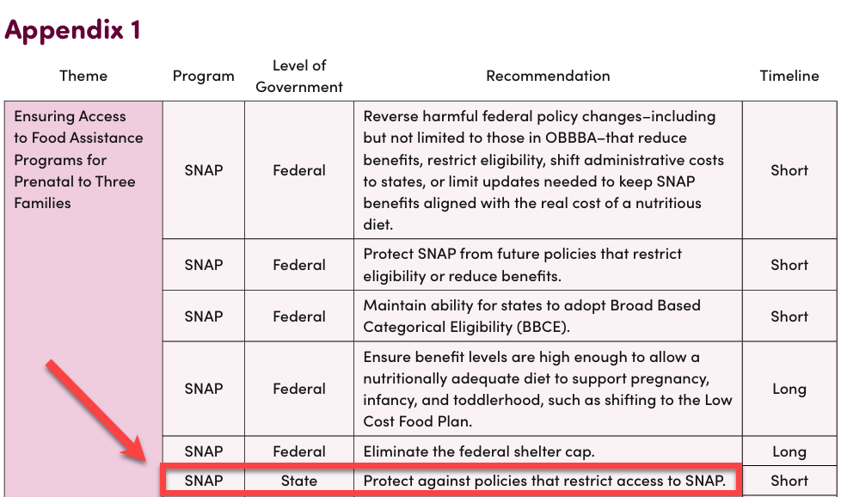

List the recommended state policy change(s) your campaign will focus on:

What type of policy change is being proposed?
Appropriations
Regulation
State-level statute passed by the legislature
Other
If other, explain

Clearly state your policy goal. How will this policy goal impact expectant parents, infants, toddlers, and their families?

Voices for Healthy Kids believes communities know what they need and can lead policy change campaigns.
- Explain how community members were involved in the selection of this policy intervention.
- Explain how the campaign/policy will build advocacy capacity in the community.
Nourish From the Start Grants will start on July 15, 2026, and end on June 30, 2027.
When would the policy be introduced (month/year)?
When would the policy potentially be passed (month/year)?

Eligible locations: [Insert the list of states/territories where you are accepting applications.]
Geographic Focus
Select the state your policy campaign is focused.

Application Narrative
Please answer each prompt with brief responses (up to 3 paragraphs). It’s okay to be concise, clear and specific is best.
Organization
- Provide an overview of your organization and mission.
- How does the policy goal tie to your organization’s mission?
- Does your organization have experience advocating for policy (federal, tribal, state, or local)? If so, please share some of your experiences and successes.
Legislative Pathway and Outlook
Tip: If you have them, include specifics like bill numbers, the committee of jurisdiction, likely champions, and expected opposition. If you don’t know yet, share your best current understanding.
- Has this policy been introduced before in your state?
  - If so, what lessons learned will you apply to this campaign?
- What is the state legislative outlook or pathway of this policy change?
- What strategies would you use to overcome opposition and solidify support?
- Is there relevant information about key state decision makers or relevant agencies that you would like us to know?
- Have you engaged with members of your federal delegation around nutrition and food issues in the past? Any insights?

Collaboration
Tip: Concrete details help here—who is at the table, how decisions are made, and how community members are compensated/recognized for their time (if applicable).
- What key relationships and collaborations currently exist, or do you plan to develop to advance the campaign’s success?
- Is there an organized coalition inclusive of people or organizations from the community supporting this policy campaign?
  - If one exists, describe the membership and decision-making process.
  - If one does not exist, outline the plan to create a coalition.
- Describe your collaboration strategy and how it will engage the co-lead/subgrantee (if applicable), share power, engage community members (with paid opportunities) and promote leadership opportunities.
- Explain if collaboration is different for the state and federal campaigns.

Campaign Strategy:
Tip: You don’t need to list everything-focus on your top tactics and who will do them, plus any key timing (e.g., pre-session, committee vote, floor vote).
- What activities, tactics and tools will your state campaign employ to pass the proposed policy? (grassroots, media advocacy, community canvasing, etc.)
- What activities, tactics, and tools will your federal campaign employ to delay or reverse the H.R. 1 SNAP changes?
- Explain how your strategy, activities and tactics will support a community-centered campaign and result in a policy that improves conditions for those facing the greatest needs.

Policy Campaign Long-Term Plan
- If successful, will this state policy require a governmental agency or organization to implement and how will you engage with these entities in the campaign?
- If the state policy does not pass in the proposed session of this grant, how will you continue the effort?
- How will you use this effort to build capacity for additional policy efforts?

Budget
View the budget template for budget line items and required budget narrative questions.
Complete the following questions based on the totals in your Budget Request document. The Budget Request document must be uploaded in the application documents section below. Legal and Indirect amounts are auto calculated in the form and are required as part of this grant.
Budget Notes:
- Requests should equal $100,000, if this form is over or under based on the auto calculations, they final budget will be edited if awarded.
- Applicants are able to allocate up to 20% of their request for lobbying tactics
- Required line items:
- Legal - 5% of the total request before indirect and included in the total non-lobbying request amount.
- Indirect - 10% of total request including Direct Costs, Purchased Services and Legal and is auto calculated and included in the total non-lobbying request amount
Budget Definitions:
Non-Lobbying/Lobbying - These fields are where you will list the amount of funding you are REQUESTING from Voices for Healthy Kids to support the respective Non-Lobbying and Lobbying tactics. These fields will total at the bottom of the budget card.
Narrative:
Budget narrative should describe details and specific activities, staff, contractors, etc. for which you will use the requested funding.

Non Lobbying Request
Lobbying Request
Request Total:
Amount Requested:
Budget Narrative
Provide a brief description of the tactics that will be supported with these funds (meetings, travel, advertising, etc.).
Include if you will be contracting with a lobbyist or other consultants and what their role will be.

Lobbying Experience
Describe your experience in direct and grassroots lobbying and how lobbying and non-lobbying expenses will be tracked.
Tip: A simple approach is fine—describe who approves lobbying activities, how time is tracked (timesheets or activity logs), and how expenses are coded (separate budget lines/cost centers) for lobbying vs. non-lobbying.

Budget – Additional questions

Additional Funds to Support This Campaign
Tip: If you’re estimating match or in-kind support, provide your best good-faith estimate and briefly note how you calculated it (staff time, meeting costs, communications support, etc.).
Tip: If you’re estimating match or in-kind support, provide your best good-faith estimate and briefly note how you calculated it (staff time, meeting costs, communications support, etc.).
Funds from Your Organization - Funds from your organization would come from your organizational budget as a match to support this campaign. There is not a required level or percentage of funds to be available (matched) from your organization, however, it is important to note the match and in-kind contribution of the applicant as it reflects the capacity of the applicant and ability to carry out the work.
Funds from Other Sources - Funds from other organizations could be additional grant funds dedicated to this campaign, coalition members supporting the campaign with a monetary match, etc. that would help carry out the work.

Funds from Your Organization
Non-Lobbying Match
Lobbying Match
Narrative
Describe how the funds from your organization will support this campaign.
Funds from Other Sources
Non-Lobbying Match
Lobbying Match
Narrative
List all additional funders currently secured to support this campaign.
If a coalition member is supporting specific campaign tactics they should be included. For example, ABC Organization will host all coalition meetings (X meetings at $$)

Documents Upload:
Application Documents:
- Upload any supplemental materials that support this application: (infographic, one page overview, video, campaign plan, website and/or social media links, media coverage link, letter of reference, cover letter etc.)

Lead Organization Documents:
Required
- IRS Letter Confirming Tax-Exempt Status (i.e., 501(c)(3) or 501(c)(4))
- Most Recent IRS Form 990 including Schedule C (Do not include Schedule B)
If applying with a fiscal sponsor the following is required:
- Copy of Fiscal Sponsorship Agreement that the applicant organization signed with the Fiscal Sponsor
- Fiscal Sponsors IRS Letter Confirming Tax-Exempt Status (i.e., 501(c)(3) or 501(c)(4))
- Fiscal Sponsors Most Recent IRS Form 990 including Schedule C (Do not include Schedule B)
Required for each co-Lead/subgrantee, if applicable:
- Non-Profit Tax-Exempt Form (i.e. 501(c)(3))
- Fiscal Sponsor Documentation (if applicable)
- A letter of support from the organization indicating the commitment and collaboration as a co-lead and/or subgrantee on this campaign.
If applying with a fiscal sponsor the following is required:
- Copy of Fiscal Sponsorship Agreement that the applicant organization signed with the Fiscal Sponsor
- Fiscal Sponsors IRS Letter Confirming Tax-Exempt Status (i.e., 501(c)(3) or 501(c)(4))
- Fiscal Sponsors Most Recent IRS Form 990 including Schedule C (Do not include Schedule B)

Agreement to Website Listing
Voices for Healthy Kids lists grantees on our website. You may decline for any reason, particularly if you are concerned the announcement will negatively impact your campaign.
Would you like your organization listed as a grantee?
Yes, please list my organization
No, please do not list my organization

