Potential Donors Worksheet

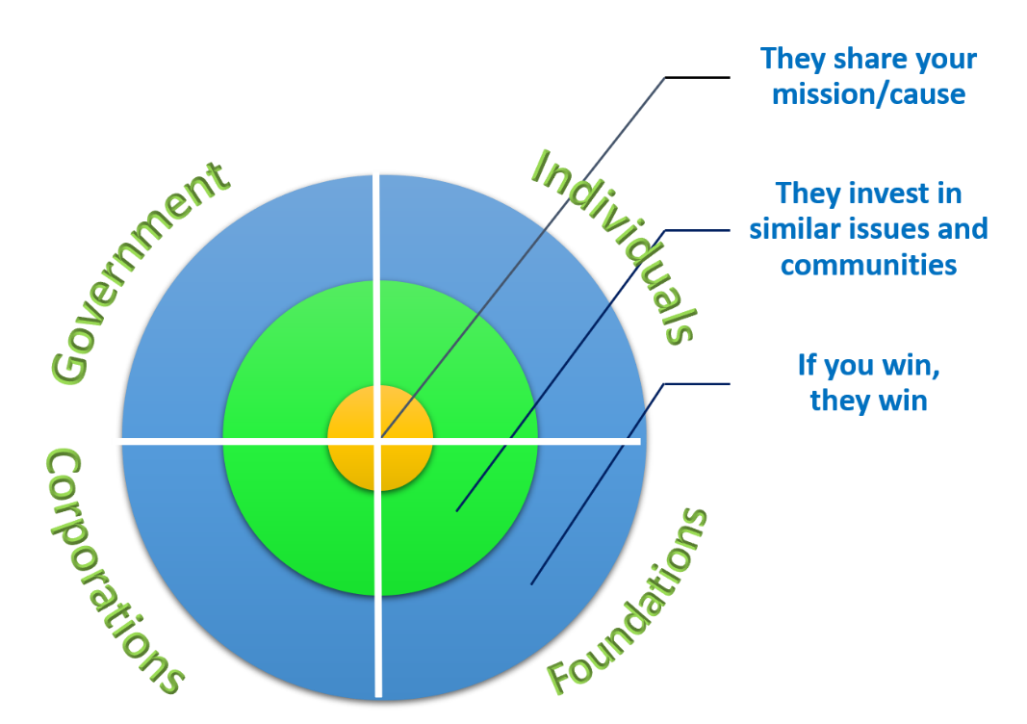Advocacy organizations frequently limit their list of potential donor prospects to a small, specific group. They tend to rely heavily on foundation support without equal time, energy and effort invested in cultivating individuals, corporations, and government as potential funders. While not every potential source of donor dollars may be a good fit for every organization, it is important to carefully consider each and make an intentional decision about which to

pursue – and which not to pursue.

There are four major groups of funders, each of which should be considered, researched, and pitched for funding:

1. Corporations and Organizations;
2. Individuals;
3. Foundations;
4. Government.

And, within each of these groups, there are three sectors we should consider:

* + Who has a mission that is an exact fit with ours? (These are the likely or “usual suspects”);
  + Who supports similar issues?
  + Who wins if we win?

|  |  |  |  |  |
| --- | --- | --- | --- | --- |
| **Group 1** | **Corporations and Organizations** | **Individuals** | **Foundations** | **Government** |
| **Their mission is an exact fit with yours** |  |  |  |  |
| **They support similar issues** |  |  |  |  |
| **They win if you win** |  |  |  |  |

|  |  |  |  |  |
| --- | --- | --- | --- | --- |
| **GROUP 2** | **Corporations and Organizations** | **Individuals** | **Foundations** | **Government** |
| **Their mission is an exact fit with yours** |  |  |  |  |
| **They support similar issues** |  |  |  |  |
| **They win if you win** |  |  |  |  |

|  |  |  |  |  |
| --- | --- | --- | --- | --- |
| **GROUP 3** | **Corporations and Organizations** | **Individuals** | **Foundations** | **Government** |
| **Their mission is an exact fit with yours** |  |  |  |  |
| **They support similar issues** |  |  |  |  |
| **They win if you win** |  |  |  |  |

|  |  |  |  |  |
| --- | --- | --- | --- | --- |
| **GROUP 4** | **Corporations and Organizations** | **Individuals** | **Foundations** | **Government** |
| **Their mission is an exact fit with yours** |  |  |  |  |
| **They support similar issues** |  |  |  |  |
| **They win if you win** |  |  |  |  |